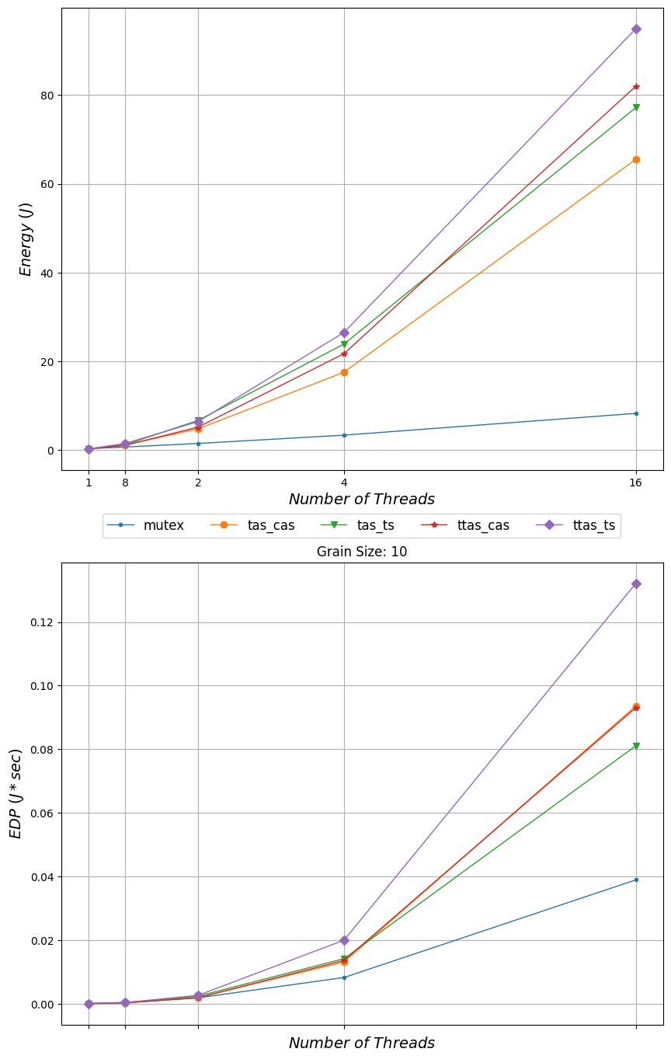

*Energy ( )*

**18**

***4***

mutex

-

*Number of Threads tas_cas + tas_ts +*

Grain Size: 10

ttas_cas

ttas_ts

*EDP (/* sec)*

*Number of Threads*